Q1. Apply hypothesis testing to compare number of admissions in hospital (adm column)

in year 2000 and 2001.

Write the details null hypothesis, alternative hypothesis, final conclusion

Ans)

Topic –

No. of Admission in hospital in year 2000 and 2001

Objective –

1) To study the no. of admission in hospital in year 2000 and 2001

2) To compare the mean of no. of admission in hospital in year 2000 and 2001

Hypothesis

1)Null hypothesis – There is no significant difference between the no. of admissions in hospital in year 2000 and 2001

2)Alternative hypothesis – There is a significant difference between the no. of admissions in hospital in year 2000 and 2001

->As we have to campare the two group (which are continuous)-> we can use independent hypothesis

Assumption

1. Data should be continuous
2. Data should follow Normal Probability Distribution (Normality)
3. Data should selected simple random sampling

Code

HortonGeneralHospital <- read_csv("D:/CDAC_Course/Advance Analytics-2023/Self_Practice/Practise Data and Question/HortonGeneralHospital.csv")

attach(HortonGeneralHospital)

View(HortonGeneralHospital)

adm_2000<-HortonGeneralHospital[HortonGeneralHospital$year==2000,c("year","Adm")]

adm_2001<-HortonGeneralHospital[HortonGeneralHospital$year==2001,c("year","Adm")]

t.test(adm_2000$Adm,adm_2001$Adm)

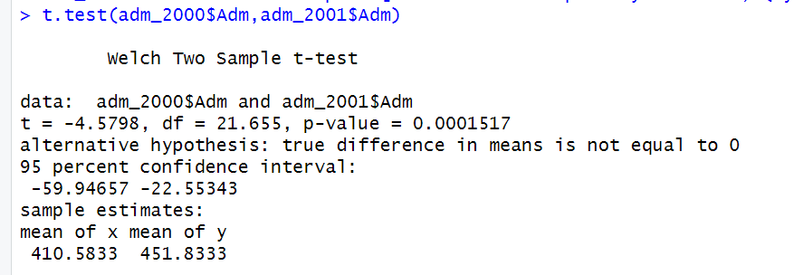

Result

As p-value<0.05 so null is rejected and alternative is accepted i.e there is significant difference between the number of admissions in hospital in year 2000 and 2001.

Q2. Check effect of three variables cardio, Resp, Hypo on number of admissions in the hospital

( adm column)

Q3. Using the given dataset, predict number of admissions (adm column) all other columns

are features.

Q4.

a boxplot

b scatterplot

c density

d histogram

e pie chart

f line plot